Elliott Waves Pattern

[The Secret Mindset](https://www.youtube.com/channel/UC9yk_6ks1g1ipJJsxtLKLcA)

[Video’s source](https://www.youtube.com/watch?v=tMjgiULV_5k)

* Fractal nature of markets: price patterns repeat themselves over and over again on all time frames
* Price movements: waves
* 2 types of price progressions:
  + Motives waves:
    - Price movements that are aligned with the larger trend
    - Classified as impulse or diagonal waves depending on the form and location on the overall structure.
  + Corrective waves:
    - Price movements that are contrary to the larger trend.
    - Typically, 3 sub-waves
* Impulse wave: typically, 3 sub-waves.
  + Among waves 1,3 and 5 there will be one extended wave which is quite a bit larger than the other two. In most cases it is the wave 3.
* Diagonal wave: looks like a wedge, either expanding or contracting

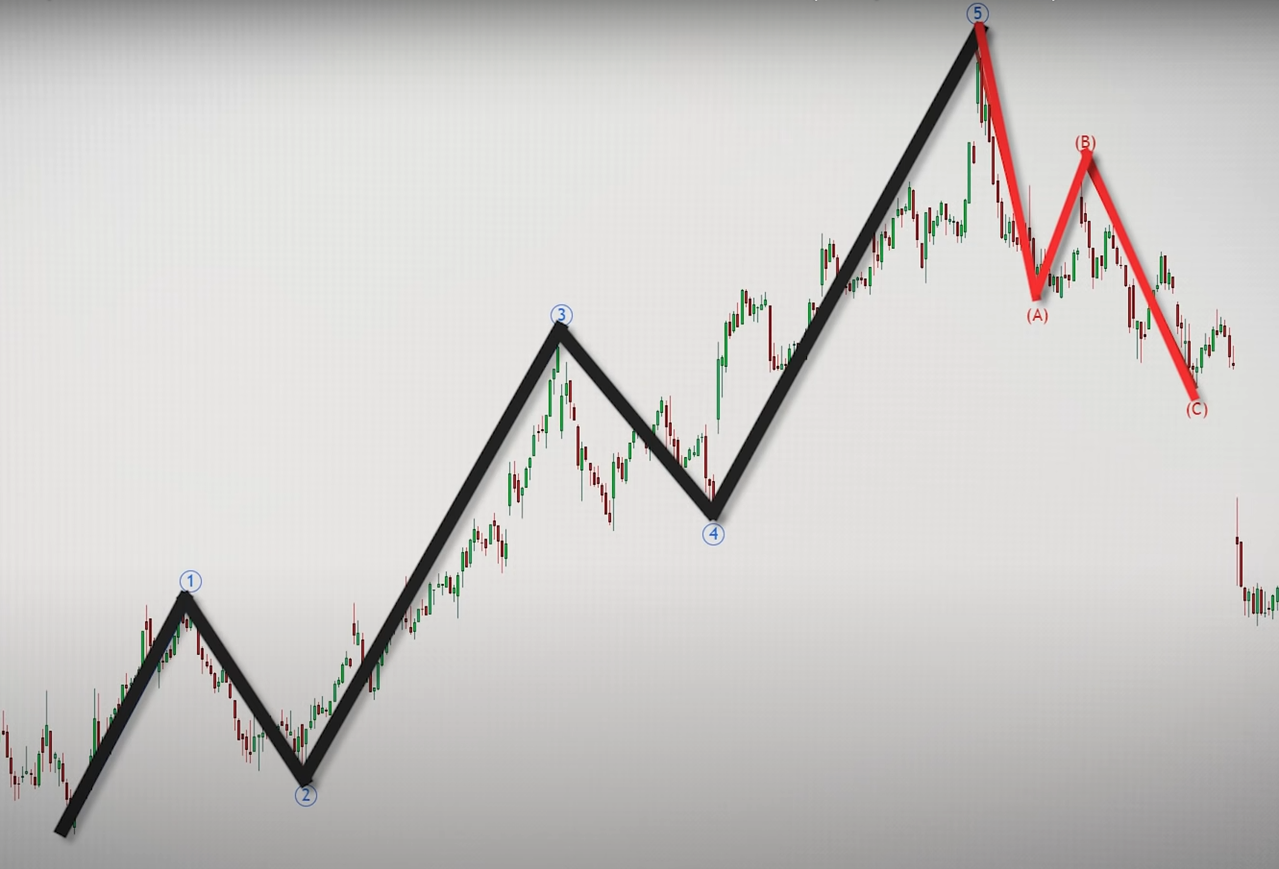

Figure 1: typical form of Elliott waves pattern

* 3 unbreakable rules (UR): if one of these rules is violated, the structure is not an impulsive wave
  + Wave 2 cannot retrace more than 100% of wave 1
  + Wave 4 cannot move into the territory of wave 1
  + Wave 3 cannot be the shortest among waves 1,3 and 5

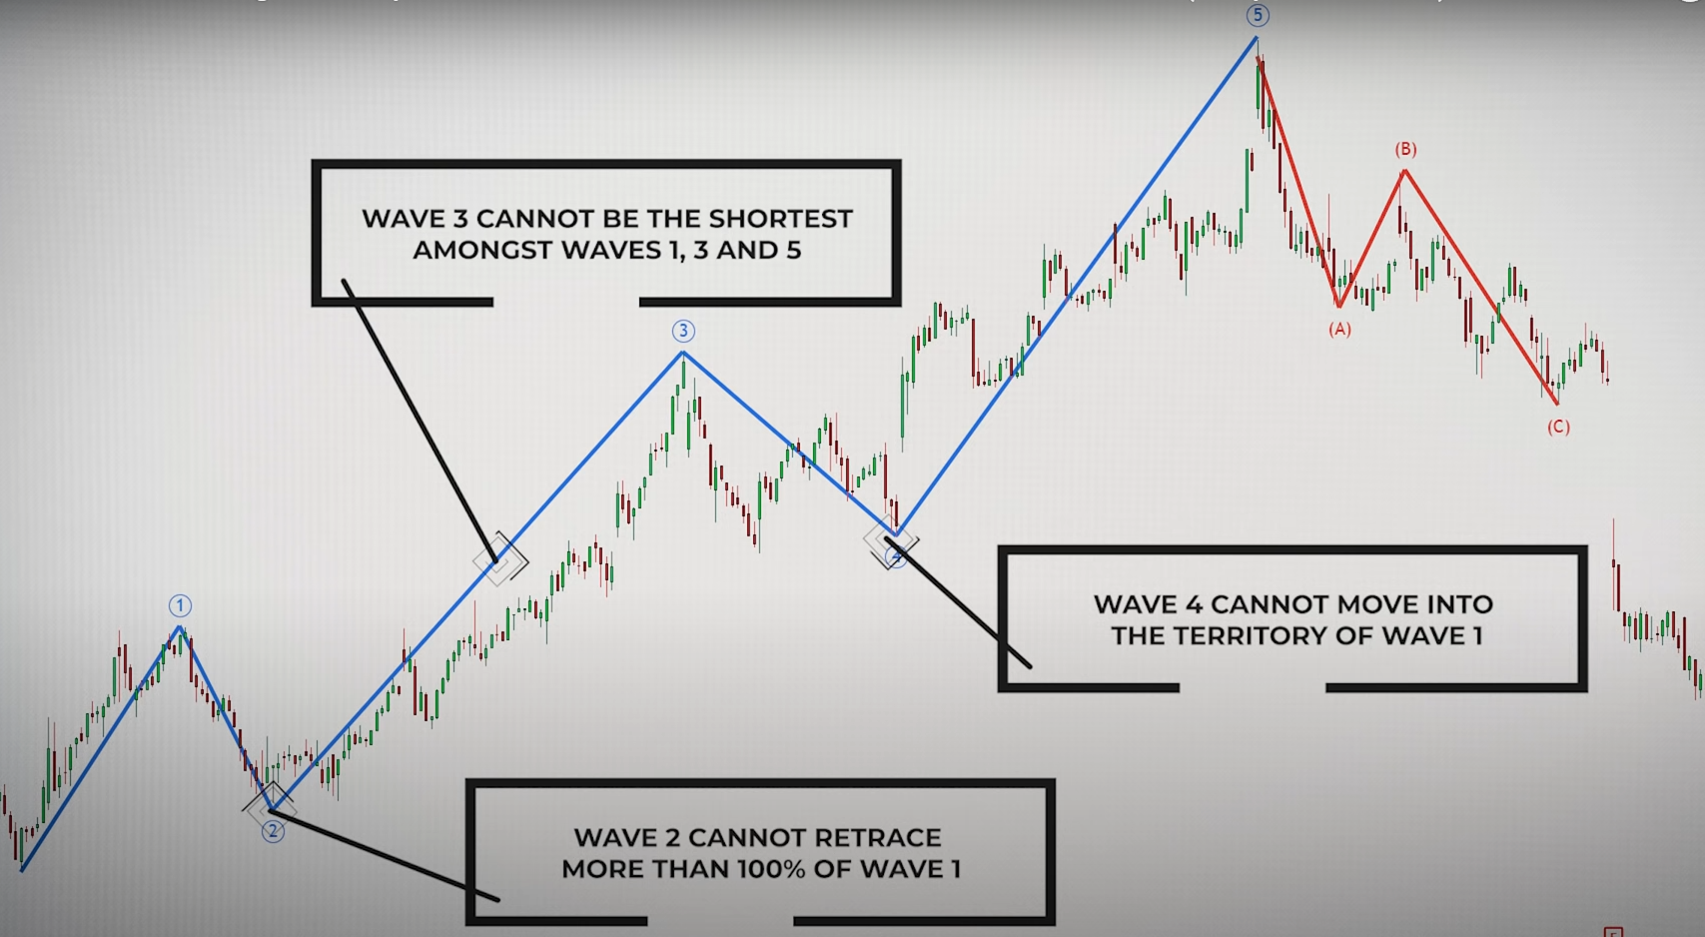

Figure 2: 3 unbreakable rules designed to distingue impulse wave

# Motive Waves structure

How to recognize waves in “real-time”:

* Wave 1:
  + Prices begin to bounce higher after a long-sustained downtrend
  + The sentiment in the market is still bearish at the start of this wave
  + The least predictive wave within the entire Elliott wave structure
  + No way to know how long this wave will last
  + A new swing high is reached
* Wave 2:
  + Will retrace a large portion of wave 1
  + Generally, retrace either 50%, 61% or even 78%
  + The market will fail to break below the wave one low
  + People begin to feel assured once again that downtrend has continued
  + Usually an ABC pattern.
  + Reminder UR: cannot retrace more than 100% of wave 1.
* Wave 3:
  + Biggest and most powerful wave
  + The sentiment in the market is bullish
  + After the wave 1 swing high break, price will begin to accelerate upward as people recognize the bullish sentiment.
  + Recognize quickly as possible in order to take advantage of the explosive moves.
  + Wave 3 offers very little retracement or they tend to be quite shallow.
  + This wave often travels 1.618 times the length of wave 1 measured from the end of wave 2. The second most common projection is 2.618.
* Wave 4:
  + Shallower retracement.
  + Often terminate at 38% or 50% of wave 3.
  + Less aggressive than wave 2.
  + 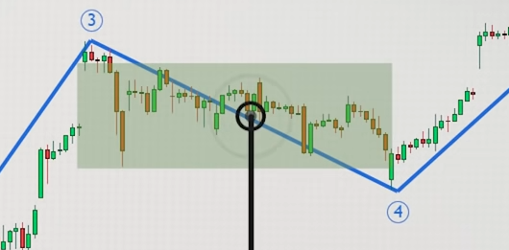Reminder UR: should not overlap into the territory of wave 1.
  + Often see as profit-taking wave: traders that bought early in wave 3 begin to liquidate their positions.
  + Often appears range bound and generates false breakout in either side of the market.
  + Be careful when taking new positions during this wave.
* Wave 5:
  + During the progression almost everyone is bullish.
  + Traders drive price higher, often to extreme valuations.
  + Momentum divergences: the velocity of the price movement higher is diminishing and you should expect the upside trend to reverse its course soon.
  + Often register lower volume compared to wave 3.
  + Projection, generally either one of those 2:
    - Will terminate upon reaching a length that is equivalent to length seen in wave 1.
    - Wave 5 travel a distance of 61% of the length of wave 1, measure from the end of wave 4

# Corrective structure

* Often a 3 waves pattern: ABC

## Wave A

* Most traders are still very bullish, and consider that wave pullback as just another minor retracement.
* It is similar to the structure of wave 1.
* Wave A is often a sharp move and may subdivide as either a five-way pattern or a three-wave pattern.

## Wave B

* Often considered as a bull trap, because it tends to create the belief that the existing trend is still healthy.
* Will often fail to surpass the wave 5 swing high.
* Try to test the wave 5 extreme, and in most cases will fail to breach it.
* Is often a deep retracement.
* Projection: Either retrace wave A by either 50%, 61% or 78%.
* It (should be) consider as a sell area.

## Wave C

* Swing low of wave A is break.
* People will become convinced that the uptrend has actually ended.
* It is similar to the wave 3 structure: tend to be relatively long and can be quite powerful from the momentum standpoint.
* Projection, travel a distance generally either one of those 2:
  + 1.27 times the length of wave A.
  + 1.61 times the length of wave A

# Elliott waves checklist

Use to confirm the wave pattern

* Wave 1, 3 and 5 are trending
* Wave 2 and 4 are corrections
* Of wave 1, 3 and 5, the 3rd must not be the shortest, but it does not have to be the longest
* Wave 2 can retrace up to 99% of wave 1.
* Wave 4 should not go into the price area of wave 2.
* Wave 2 and 4 must display alternation as many ways as possible (must be different):
  + Price: wave 2 compared to wave 4 may be obviously smaller/larger.
  + Time: take much more/less time.
  + Pattern: wave 2 may be a simple ABC and wave 4 could be more complex.

# Examples

Train to recognize Elliott waves pattern

